PRESS RELEASE

ALPOLIC™

Mitsubishi Polyester Film GmbH, Kasteler Straße 45, 65203 Wiesbaden, Germany

Press contact:

Liane Hötger

teampenta Communication | Seibertzweg 2 | 44141 Dortmund |Phone: 0231-55695264

Wiesbaden, 04 December 2019

Positive ecological balance for ALPOLICTM aluminium composite panels
ALPOLIC™ receives Environmental Product Declaration (EPD)

In the construction industry, the sustainability and life cycle assessment of building elements used is an essential decision criterion for clients, architects and planners. Sustainability is a fundamental part of ALPOLIC™'s corporate philosophy. This includes careful and respectful handling of resources and production in accordance with the strictest safety and environmental regulations. Now the positive ecological balance of the ALPOLIC™ aluminium composite panels has also been certified in the form of an EPD (Environmental Product Declaration) by the testing institute Kiwa BCS Öko-Garantie GmbH. This EPD documents the sustainability of the products from the cradle to the factory sector (cradle-to-gate) and serves as proof for a sustainability assessment of buildings.

Life cycle assessment from the cradle-to-gate
Environmental Product Declarations (EPDs) enable companies to communicate the environmental impact of their products transparently. They provide information on all relevant factors during the entire product life cycle. ALPOLIC™, together with Kiwa BCS Öko-Garantie GmbH, has drawn up specific requirements and rules for composite materials for the preparation of environmental product declarations. These so-called Product Category Rules (PCR) form the basis for the uniformly applicable calculation rules for the life cycle assessment and for the requirements for the background report.

The environmental product declaration issued is a Type III environmental declaration, which was drawn up on the basis of EN 15804 and ISO 14025. It contains all relevant information on the use of energy and resources and to what extent the products contribute to the greenhouse effect, acidification, eutrophication, destruction of the ozone layer and smog formation. An average product from the product series ALPOLIC™ A2, ALPOLIC™/fr and ALPOLIC™ reAL Anodised was considered. The environmental impacts for the product with the highest raw density were reported. The EPD applies exclusively to the products mentioned and includes their life cycle assessment-based indicators from the cradle to the plant sector (cradle-to-gate). It is valid from October 2019 to October 2024.

ALPOLICTM is committed to sustainability
ALPOLIC™ has been actively committed to sustainable building for many years. With the creation of the EPD, the company is underscoring its commitment to sustainability. The environmental product declarations are among the most important instruments for certifying the sustainability of buildings, as they contain objective facts about the impact of the products described over their entire life cycle on people and the environment. This enables building owners, architects and specialist planners to prove the sustainability of buildings right from the planning phase. The environmentally relevant assessment criteria for certification can thus be fulfilled without great effort. Building certification not only makes an important contribution to protecting the environment, but in many cases also increases the value of the property.

ALPOLIC™ will continue to advocate environmentally friendly solutions and products as well as sustainable construction in the future. For more information on sustainability and the EPD, please visit www.alpolic.eu.

Text length:

431 words, 3.449 Characters (incl. spaces)

pictorial material:

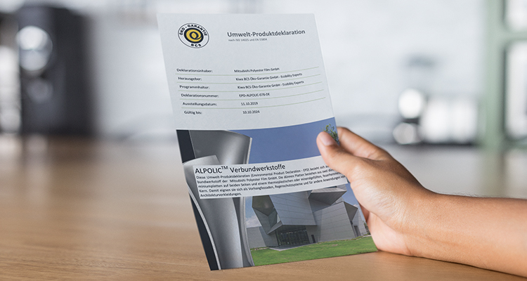

Environmental Product Declaration (EPD) for ALPOLIC™ Composite Materials

Image source: ALPOLIC™ ©Placeit

Publication free of charge. We are glad to receive a specimen copy.
About ALPOLIC™
ALPOLIC™ is a trademark of Mitsubishi Chemical Corporation. For over 47 years, planners, architects, builders and fabricators worldwide have relied on ALPOLIC™ aluminium composite panels for rear-ventilated building façades.

BE.SAFE. is the claim that ALPOLICTM not only has as a product, but holistically as a corporate philosophy. This is backed by tangible arguments for more quality and safety for the building facade - from fire protection to sustainability. With numerous innovations, ALPOLIC™ has significantly influenced market trends and set new standards. ALPOLIC™ was the first supplier of composite panels with decorative surfaces, natural metals and genuine anodised aluminium in a coil coating process. All aluminium composite panels are supplied as standard in quality class FR (flame-retardant) or A2 (non-combustible) and thus also meet the high requirements of international fire protection guidelines. ALPOLIC™ exclusively uses LUMIFLON™ for its colour coatings. One of the world's highest quality coatings, based on a fluoropolymer coating (FEVE). In the 2014 newly built plant in Wiesbaden, with a production capacity of 1 million square metres, the aluminium composite panels are quality manufactured under the strictest safety and environmental regulations. In addition, Mitsubishi Chemical Corp. is committed to continuous improvements in environmental protection far beyond the statutory requirements. ALPOLIC™ composite panels are the only ones in the industry that are almost 100 percent recyclable. The waste generated in the production process is also collected and returned to the recycling cycle.

We are happy to answer your questions:

Manufacturer information:  ALPOLIC  Mitsubishi Polyester Film GmbH  Kasteler Straße 45  65203 Wiesbaden  Phone: +49 611 962 3482  Fax: +49 611 962 9059  www.alpolic.eu | Press contact:  teampenta GmbH & Co. KG  Liane Hötger  Seibertzweg 2  44141 Dortmund  Phone: +49 231 556952-64  liane.hoetger@teampenta.de  www.teampenta.de

