PRESS RELEASE
ALPOLIC™

Mitsubishi Polyester Film GmbH, Kasteler Straße 45, 65203 Wiesbaden

Press contact:

Liane Hötger

teampenta Communication | Seibertzweg 2 | 44141 Dortmund |Tel.: 0231-556952-64

Wiesbaden, 05. October 2020

ALPOLICTM A1: More (fire)safety for the façade cladding of high-rise buildings

Especially in cities and conurbations, the trend is towards high-density construction - high-rise construction is on the rise. As building heights increase, so do the requirements for safety and fire protection. For good reason: because a faulty fire protection concept can not only cause high material damage in an emergency, but also endanger human lives. This is proven by the repeated occurrence of high-rise building fires with devastating consequences, which are also due to the use of combustible building materials. Particular attention is paid to façade cladding - because this has repeatedly been identified as a possible "fire accelerator". For building owners, planners and architects, it is therefore more important than ever to pay attention to the fire safety of the materials used when planning buildings.

For the granting of a building permission, a corresponding fire protection concept and fire protection certificate must be provided for each building. Particularly for high-rise buildings and high-risk buildings (hospitals, hotels, retirement homes, etc.), strict legal regulations apply in this respect - both for building planning and the selection of materials. According to the legislator, only non-combustible building materials must be used. This also applies to façade materials, as they are an essential part of the building envelope and thus make a significant contribution to the fire safety of a building. Since architects and planners bear a decisive responsibility in the planning and execution of the fire protection measures required by law and building regulations, the choice of a suitable façade material is therefore of the utmost importance.

ALPOLICTM A1 - first composite material worldwide with A1 classification
Against this background, the Mitsubishi Chemical Corporation has developed ALPOLICTM A1, the world's first aluminium composite material (ACM) classified according to the European Fire Protection standard DIN EN 13501-1, Euroclass A1. This means that the material is non-combustible and does not develop any smoke in the event of fire. In addition, the heat potential of the core material is max. 1 MJ/kg. ALPOLICTM A1 is therefore particularly recommended for applications in the building industry or in architecture where there are increased requirements for fire protection.

ALPOLICTM A1 - much more than safe
ALPOLICTM A1 is a three-layer composite material (ACM) produced by laminating two aluminium sheets to both sides of a core material. Thanks to its excellent surface finish, flatness, colour variety and very good processing properties, ALPOLICTM offers almost unlimited design possibilities in both existing and new buildings.

ALPOLICTM also convinces in terms of sustainability with a positive eco-balance - an important selection criterion even in the early planning phase.
The composite panels are produced according to the strictest environmental regulations and are almost 100 percent recyclable. Even the waste generated in the production process is collected and returned to the material cycle.

Text volume:

392 Words, 3.189 Characters (including spaces)

Picture material:

Caption:
Maximum fire safety for high-rise and high-risk buildings

Picture source: © iStock | Innovatedcaptures

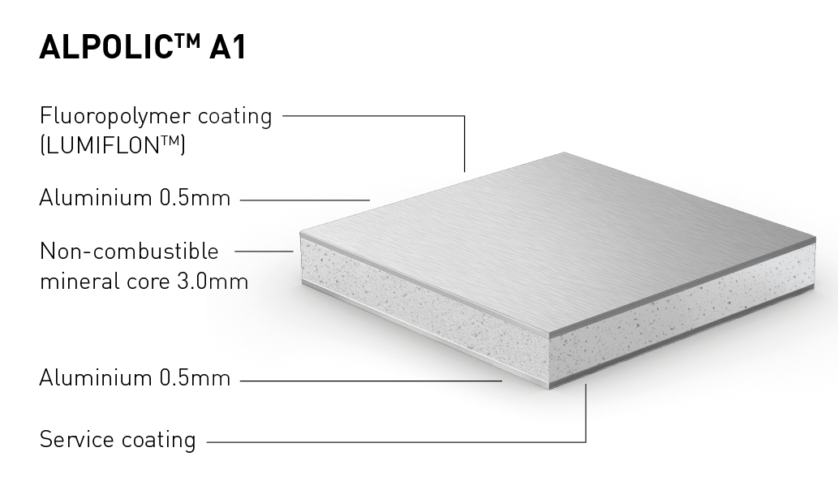
Caption:
It all comes down to the core: ALPOLICTM A1 aluminium composite panel with a non-combustible mineral core

Picture source: ALPOLIC™

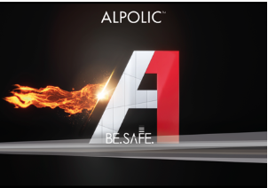
Caption:
ALPOLICTM A1 World's first aluminium composite panel with A1 classification

Picture source: ALPOLIC™

Reprint free of charge. We would be pleased to receive a copy.

About ALPOLIC™
ALPOLIC™ is a trademark of Mitsubishi Chemical Corporation. For over 49 years, planners, architects, builders and fabricators worldwide have relied on ALPOLIC™ aluminium composite panels for ventilated building façade.

BE.SAFE. is the claim that ALPOLICTM not only occupies as a product philosophy, but also as a holistic corporate philosophy. Behind this are solid arguments for more quality and safety for building façades - from fire protection to sustainability. With numerous innovations, ALPOLIC™ has significantly influenced market trends and set new standards. ALPOLIC™ is the first manufacturer of composite panels with decorative surfaces, natural metals and genuine anodised in a continuous coating process and, most recently: the first composite panel with A1 classification. All aluminium composite panels are supplied as standard in the FR (flame-retardant) A2 (non-combustible) or A1 (non-combustible) quality class and thus also meet the high requirements of international fire protection guidelines. For its colour coatings ALPOLIC™ uses LUMIFLON™ exclusively. One of the world's highest quality coatings, based on a fluoropolymer coating (FEVE). In the new plant in Wiesbaden, which was built in 2014 and has a production capacity of 1 million square metres, the aluminium composite panels are manufactured to the highest quality under the strictest safety and environmental regulations. In addition, Mitsubishi Chemical Corp. is committed to continuous improvements in environmental protection far beyond the statutory requirements. ALPOLIC™ Composite panels are the only ones in the industry that are almost 100 percent recyclable. Waste generated during the production process is also collected and returned to the material cycle.

We will gladly answer your questions:

Manufacturer information:  ALPOLIC  Mitsubishi Polyester Film GmbH  Kasteler Straße 45  65203 Wiesbaden  phone.: +49 611 962 3482  fax: +49 611 962 9059  www.alpolic.eu | Press contact:  teampenta GmbH & Co. KG  Liane Hötger  Seibertzweg 2  44141 Dortmund  Tel.: +49 231 556952-64  liane.hoetger@teampenta.de  www.teampenta.eu

